|  |  |  |
| --- | --- | --- |
| **Guide Name** | | **Panel Head** |
|  | Dr. Prabakeran S | Dr. Prabakeran S |
|  |  |  |
|  | **Faculty Advisors** | **Project Domain** |
|  | Dr. Arun A, Dr. Saranya G | Deep Learning, Automation |
| M |  |  |
|  | **Student(s) Details: Name** | **Passport size photo(s)** |
|  | 1. Jacob Kevin P 2. Paul Bezaleel T 3. Ethan RM Asher |  |
|  |  |  |

Registration Number(s)



1. RA2111030010161

2. RA2111030010197

3. RA2111030010163

**Email ID(s)&Mobile Number(s)**

|  |  |
| --- | --- |
| 1: jp0746@srmist.edu.in | 2: pt7990@srmist.edu.in |
| 3:er3157@srmist.edu.in | 4: |

**Abstract Architecture Diagram**

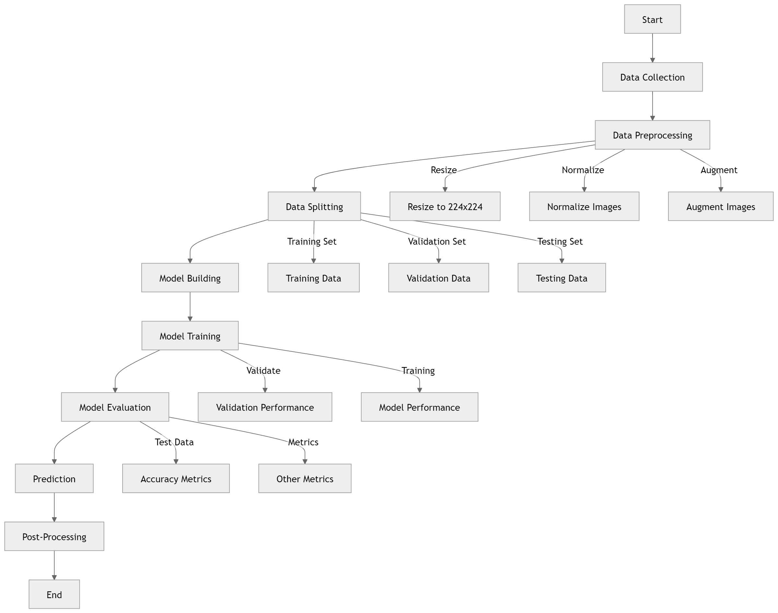

This project focuses on developing an advanced breast cancer detection system utilizing deep learning techniques. By applying convolutional neural networks (CNNs) to histopathological images, the system classifies images into benign or malignant categories with high accuracy. The approach incorporates data balancing using Synthetic Minority Over-sampling Technique (SMOTE) to address class imbalances. The pipeline includes image preprocessing, data augmentation, model training, and evaluation. The final system delivers reliable predictions and can significantly enhance early breast cancer detection and diagnosis.

**Significance of the Project Conclusion**

The significance of this project is its potential to enhance breast cancer diagnosis by leveraging advanced deep learning techniques. By improving accuracy and early detection through automated analysis of histopathological images and addressing class imbalances with SMOTE, the project aims to provide a more efficient, reliable, and scalable diagnostic tool. This innovation can lead to better patient outcomes and advance medical research.

The project concludes that integrating deep learning models with histopathological image analysis significantly improves breast cancer detection accuracy. By utilizing advanced techniques like SMOTE for handling class imbalances and employing hybrid CNN architectures, the system offers a more precise and efficient diagnostic tool. This advancement has the potential to enhance early detection, reduce diagnostic errors, and ultimately contribute to better patient care and outcomes.

**Conference/Journal Publication Details (Mandatory)**

* Breast Cancer Histopathological Image Classification: A Deep Learning Approach. Authors: Mehdi Habibzadeh Motlagh et al.
* Breast Cancer Classification Using Deep Learning Approaches and Histopathology Image: A Comparison Study. Authors: Faezehsadat Shahidi et al.
* Breast Cancer Histopathology Image Classification Using an Ensemble of Deep Learning Models. Authors: Zabit Hameed et al.
* Squeeze-and-Excitation Networks. Authors: Jie Hu et al.
* Efficient Breast Cancer Classification Network with Dual Squeeze and Excitation in Histopathological Images. Authors: Md. Mostafa Kamal Sarker et al.
* Detecting Affect States Using VGG16, ResNet50 and SE-ResNet50 Networks. Authors: Dhananjay Theckedath & R. R. Sedamkar
* Breast Cancer Diagnosis in Histopathological Images Using ResNet-50 Convolutional Neural Network. Authors: Qasem Abu Al-Haija & Adeola Adebanjo